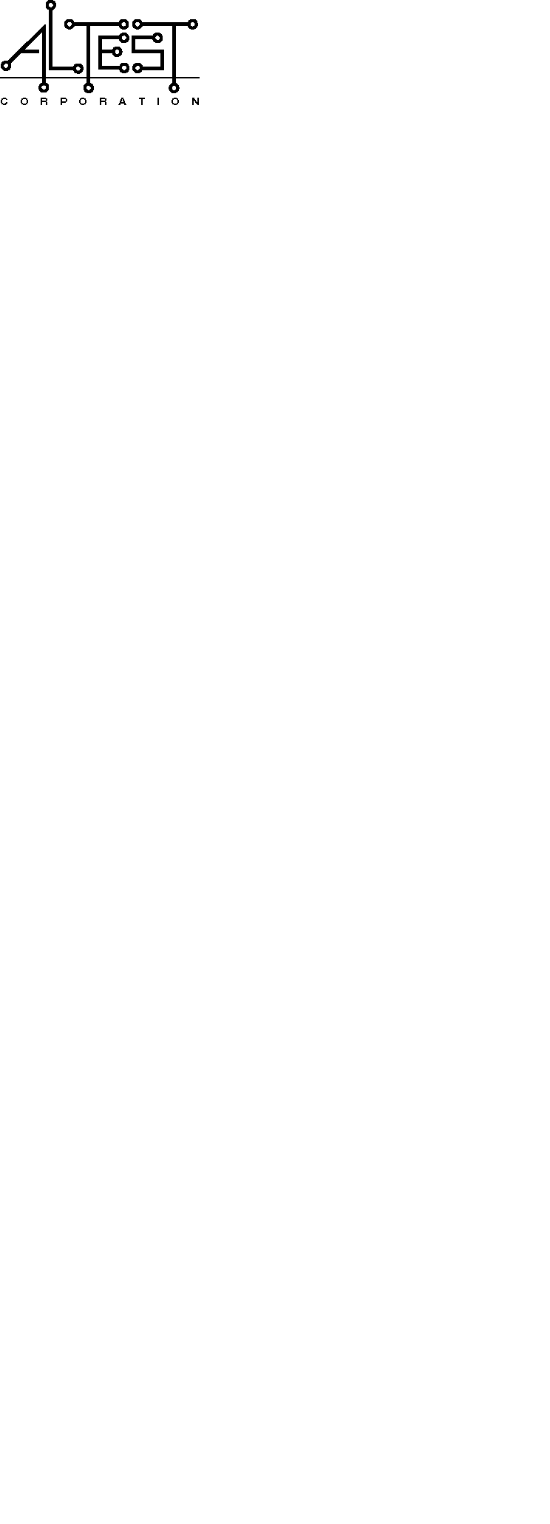
QUOTATION E-MAIL

ALTEST Corporation University of Berkeley
898 Faulstich Court 601 Campbell Hall #3411
San Jose, CA 95112 Berkeley, CA 94720

Tel: (408) 436-9900 X211 Tel: (510)-642-4016

Fax: 408) 436-9911 FAX: (510) 642-3411
Email: bseng@altestcorp.com Email: efields@uclink.berkeley.edu
From: Brian Seng Attn: Edward Fields

RE: QUOTATION # P4947 DATE: 2/25/08

Hello Ed,

Here is the quote for:

Item#: Description/Part Number: Qty of: Unit Price (each)
1 ASSEMBLY, P/N: 1050-A 400 $5.00
2 NRE- (STENCIL/PROGRAM) 1 $450.00

Terms/Conditions:

1) Delivery is 3-4 DAYS A.R.O.
2) This quote is valid for 30 days.
3) Payment is Net 30 Days, FOB San Jose, CA.
4) All materials are to be supplied by UC BERKELEY
5) No functional testing include above pricing

Thank you for the opportunity of making this offer. Should you have any questions, please contact me.

Sincerely,

Brian Seng
(408) 436-9900 ext. 211

(Page 1 of 1)

Design, Fabrication, Test / Commercial Boards
Complete Turnkey Assembly Components, Electronics

